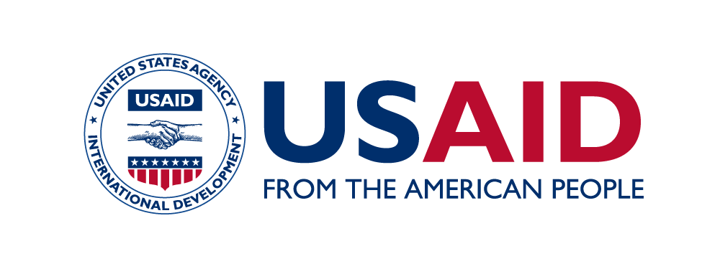 |  | 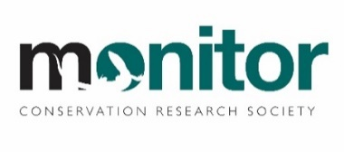

Launch of USAID Wildlife Asia’s

2020 Counter Wildlife Trafficking

Digest Report

Date: Friday May 21, 2021

Time: 9:30-10:30 am (Bangkok, Hanoi, Jakarta GMT+07:00)
Virtual Platform Link: Digest IV Launch Joining Link

Introduction
The USAID Wildlife Asia Activity is a five-year, $24.5 million, regional counter wildlife trafficking initiative addressing the trafficking of pangolins, rhinos, elephants and tigers by working to reduce consumer demand for wildlife parts and products, strengthen law enforcement capacity and coordination, enhance policy, legislation and jurisprudence and improve regional action to reduce wildlife crime in Southeast Asia and China.

To support this process, USAID Wildlife Asia aims to provide an evidence base to support decision-making about priority interventions in policy, law enforcement and consumer-demand reduction. This is done through the systematic compilation of open-source information which is then analyzed to capture the status, trends and changes in patterns of the illegal wildlife trade. The information is then documented in USAID Wildlife Asia’s annual Counter Wildlife Trafficking (CWT) Digest reports which include recommendations targeting the U.S. Government, national government counterpart agencies, and the broader CWT conservation community. It is also aimed at being a resource and reference document for a broader range of stakeholders including the private sector, journalists, students, academics and other interested parties.

To date, USAID Wildlife Asia has released two three reports; one for 2017, one for 2018, and one covering 2019. We are now excited to launch the fourth report in the series covering 2020.

Draft Agenda
Time | Topic | Speaker/Presenter
9:30-9:35 am | Call opens and participants are welcomed to the meeting  Background and purpose of USAID Wildlife Asia’s Digest Reports | Peter Collier, Chief of Party, USAID Wildlife Asia
9:35-9:40 am | Opening remarks | Deputy Assistant Commissioner Jim Wee, Executive Director, ASEANAPOL Secretariat
9:40-9:55 am | Digest IV key findings and highlights | Chris Shepherd, Founder and Executive Director, Monitor
9:55-10:05 am | Lessons learned and next steps | Sulma Warne, Senior Technical Advisor, USAID Wildlife Asia
10:05-10:15 am | Impacts of Covid on wildlife trafficking | Giovanni Broussard, UNODC Regional Coordinator, Wildlife and Forest Crime Programme
10:15-10:30 am | Q&A session | Discussion moderated by Sulma Warne, Senior Technical Advisor, USAID Wildlife Asia, and Chris Shepherd, Founder and Executive Director, Monitor
10:30 am | How to get your hands on a copy and closing remarks | Peter Collier, Chief of Party, USAID Wildlife Asia

